Impact of Movies on College Choices: Media Narratives, Perceived Fit, and Enrollment Intentions
Author: Ethan Walker
Institution: Monta Vista High School, CA

Abstract
Movies and movie-like entertainment narratives (including streaming series) shape how students imagine college: what “good” campuses look like, who belongs there, and what certain majors or professions feel like. This paper synthesizes media-effects theory (cultivation, social learning, and narrative transportation) and college-choice research to explain when and how movies can influence student preferences. We then present a case study of the ‘CSI effect’ in forensic-science education, using published survey data from undergraduate forensic students (n = 135) to show how pervasive entertainment viewing is and how it correlates with role-model formation, perceived realism, and expectations about professional ethics. In the case study, 91.1% of students reported watching forensic-science shows and 79.8% had watched CSI at some point; yet only 3% rated television dramas as an important source of bioethical information suggesting that entertainment can attract interest while still being viewed as epistemically weak once students enter formal study (Weaver et al., 2012). To connect these micro-level mechanisms to broader college-search behavior, the paper incorporates recent survey statistics showing how large application pools have become and how digital media channels (notably YouTube and TikTok) now function as search tools in the college-selection process (Jenzabar/Spark451, 2024; NACAC, 2023). We conclude with practical implications for students, educators, and admissions offices, emphasizing media literacy, expectation management, and ethical communication.
Keywords: college choice; movies; media effects; narrative transportation; social learning; CSI effect; enrollment marketing

Introduction
Choosing a college is not only a rational comparison of costs, rankings, and programs; it is also an identity project. Students ask, often implicitly: “Can I see myself there?” Movies (and closely related screen media) answer this question with vivid, emotionally charged stories elite lecture halls, dramatic dorm life, clubs, sports, romance, rivalry, and career ‘origin stories.’ These portrayals can function as informal “samples” of campus life long before a student ever visits a campus.
At the same time, the influence of movies is rarely direct or deterministic. College choice is shaped by multiple stages of predisposition, search, and final selection, and by constraints such as affordability and admission probability (Hossler & Gallagher, 1987). Movies more often operate as a background influence: shaping what students notice, what they aspire to, and what they consider prestigious or ‘fun.’ This paper asks: How do movies influence college choices, through what psychological mechanisms, and with what measurable patterns?

Conceptual Framework: Why Movies Can Influence College Preferences
Three research traditions help explain why movies may influence college preferences:
1) Cultivation theory proposes that repeated exposure to media portrayals can shape viewers’ perceptions of social reality over time (Gerbner & Gross, 1976). If campuses are consistently depicted as wealthy, hyper-social, and driven by prestige, students may infer that those traits are “normal” or required for success.
2) Social cognitive theory suggests that people learn by observing models, especially when those models are rewarded and presented as attractive or competent (Bandura, 2001). A charismatic on-screen student, professor, or professional can make a major feel desirable and a college environment feel worth pursuing.
3) Narrative transportation describes how being absorbed in a story can change beliefs and attitudes, partly by reducing counter-arguing and increasing emotional engagement (Green & Brock, 2000). When a film transports a viewer, the college-like setting is not “information,” it is lived experience making the viewer more likely to internalize impressions about fit.

Literature Review: Media, Branding, and the College-Choice Process
College-choice scholarship often treats information sources (counselors, parents, campus visits, websites) as inputs into a staged decision process (Hossler & Gallagher, 1987). In today’s environment, entertainment media intersects with this process by influencing (a) the aspiration stage (what kinds of colleges feel desirable), (b) the search stage (what students look for online), and (c) the interpretation stage (how students interpret campus cues like architecture, traditions, or student culture).
Digital platforms now blur the line between entertainment and search. In a large U.S. survey of college-bound seniors and parents (summer 2024), 45% of students applied to 10 or more schools (up from 39% in 2023), and 60% reported spending 3+ hours on social media daily; Instagram, YouTube, and TikTok were the top channels used during the college search (Jenzabar/Spark451, 2024). These platforms distribute both official college videos and entertainment-style content (campus vlogs, “day in my life” edits, and short-form narratives). Empirically, research on social media and college choice suggests that these channels shape perceptions of fit, campus culture, and institutional personality (Turner, 2017).
However, rigorous measurement of ‘movies’ specifically is limited. Most studies operationalize screen media more broadly (television, streaming, YouTube, and film). Therefore, this paper uses a focused case study where entertainment narratives are clearly tied to a field of study and student motivations: forensic science and the ‘CSI effect.’

Method
This paper uses a mixed approach:
• Narrative review: We integrate established media-effects theory and college-choice theory to build a mechanism-based model.
• Case study: We analyze published survey findings from an undergraduate forensic-science program reported by Weaver et al. (2012), focusing on (a) viewing frequency, (b) role-model preferences, and (c) how students evaluate ethical realism.
• Contextual statistics: We incorporate contemporary college-search and application behavior statistics from national surveys to situate the case study within current enrollment dynamics (NACAC, 2023; Jenzabar/Spark451, 2024).
Because this paper is secondary research, it does not claim causal inference. Instead, it identifies plausible pathways and triangulates evidence consistent with those pathways.

Case Study: The CSI Effect and Forensic-Science Students
The ‘CSI effect’ is commonly discussed as a courtroom phenomenon (jurors’ expectations for forensic evidence), but it also has an educational dimension: the glamorized depiction of forensic work can increase student interest in forensic-science degrees (Weaver et al., 2012). Weaver et al. (2012) surveyed students enrolled in a forensic-science program in Australia; 135 of 215 students (63%) completed the survey, and the sample closely matched the program population on age, gender, and country of birth.
Viewing prevalence was extremely high. 98.5% had watched television in the past year, 97.0% reported watching movies, and 91.1% watched forensic-science shows (Weaver et al., 2012). The most-viewed forensic dramas ever watched included NCIS (81.1%) and CSI (79.8%). Regular (at least weekly) viewing was also substantial: 27.9% watched NCIS weekly, 24.8% watched Dexter weekly, 24.5% watched Bones weekly, and 19.3% watched CSI weekly (Weaver et al., 2012). These patterns illustrate a key point: entertainment exposure is not occasional it can be routine, social (often watched with family/friends), and therefore identity-relevant.
Role models emerged within entertainment narratives. When asked which characters served as role models, students most commonly selected Abby Sciuto (37.8%), Dr. Temperance Brennan (23.7%), and Dexter Morgan (19.3%). In contrast, Horatio Caine was rated the least popular role model (24.4%) (Weaver et al., 2012). Such preferences matter because role-model identification is a mechanism through which media can influence aspirations and perceived fit (Bandura, 2001).
Crucially, the survey also shows a limit of entertainment influence once students enter formal learning. Although students frequently watched these shows, only 3% rated television dramas as an important source of information about bioethical issues (Weaver et al., 2012). Students also rated the accuracy of ethical and forensic issues very low (median 1–2 on a 0–5 accuracy scale) and often criticized unrealistic timelines and procedures (Weaver et al., 2012). Yet nearly half (49.6%) reported being asked by friends or family for their opinion about forensic or ethical issues seen on TV, suggesting that the entertainment narrative still positioned them socially as “experts-in-training.”
Interpretation for college choice: this case supports a two-stage influence model. Stage 1 (pre-enrollment): screen narratives attract attention and help students imagine themselves in a field. Stage 2 (post-enrollment): students recalibrate expectations, often rejecting the shows as accurate while retaining the identity and social signaling benefits of the field.

Table 1
Television viewing habits reported by forensic-science students (n = 135)
Forensic drama | Ever watched (%) | Watched ≥ once/week (%) | Watched with family/friends (%)
NCIS | 81.1 | 27.9 | 50.9
CSI | 79.8 | 19.3 | 44.7
Bones | 64.7 | 24.5 | 39.8
Dexter | 61.9 | 24.8 | 33.0
Note. Data adapted from Weaver et al. (2012).

Discussion: What This Means for College Choice
Across theory and evidence, movies can influence college choices through four pathways:
1) Prestige and “default” expectations (cultivation). Repeated elite-campus imagery can normalize high-status cues ancient architecture, wealthy student lifestyles, and dramatic achievement arcs leading students to over-weight prestige signals in their own decision heuristics (Gerbner & Gross, 1976).
2) Identity and role-model matching (social learning). Students may ‘try on’ majors and campuses by identifying with characters. The forensic-science case illustrates that role-model selection is measurable and patterned (Weaver et al., 2012), consistent with observational learning mechanisms (Bandura, 2001).
3) Emotional persuasion (transportation). When a narrative is compelling, it can function like a simulated campus visit: viewers feel the texture of the environment, which can shift attitudes about fit (Green & Brock, 2000).
4) Search amplification in the digital era. Contemporary search behavior is increasingly mediated by entertainment-like short video. In 2024 survey data, Instagram, YouTube, and TikTok were top channels used during college search, and large application volumes (10+ schools) became more common (Jenzabar/Spark451, 2024). Movies can act as a “spark,” while social platforms supply the actionable next step: campus vlogs, acceptance-reaction videos, and program explainers.
Importantly, the case study indicates that entertainment’s informational authority may be low once students engage with formal coursework. This suggests a balanced conclusion: movies are better at motivating and shaping imagination than at providing accurate guidance. For students, the goal is not to avoid movie influence (impossible), but to recognize it and supplement it with reliable sources.

Practical Implications
For students:
• Treat movies as “mood boards,” not manuals. Use them to identify what excites you (community, labs, debate culture), then verify reality via course plans, placement data, and student interviews.
• Ask “What is the story selling?” (status, romance, rebellion) and separate that from academic fit.
For educators and counselors:
• Build media literacy into advising: discuss common cinematic myths (instant breakthroughs, glamorous labs, effortless internships).
• Provide reality checks early (e.g., typical research timelines, prerequisite intensity), which can reduce mismatch and attrition.
For admissions offices:
• Recognize the narrative competition. Students are saturated with entertainment narratives; institutional communication should address values, culture, and student experience clearly and authentically.
• Leverage student-generated video ethically high trust, low polish content can counteract cinematic exaggeration (Jenzabar/Spark451, 2024).

Limitations and Future Research
Evidence on movies specifically (as distinct from broader screen media) remains limited, and much of the strongest available evidence is domain-specific (e.g., forensic science). Future research should: (a) use longitudinal designs to track whether exposure to specific films predicts application behavior, (b) compare effects across demographic groups and first-generation status, and (c) distinguish between ‘institution choice’ (which college) and ‘program choice’ (what major).

Conclusion
Movies can influence college choice by shaping aspirations, perceived fit, and identity especially before students have direct experience with a campus or a field. The forensic-science case study shows how pervasive entertainment viewing is among students and how it can create role-model effects while still being dismissed as a weak informational source once formal study begins (Weaver et al., 2012). In a college-search environment increasingly driven by video-first platforms and large application pools, understanding media influence is not optional; it is part of making a grounded, self-aware decision (Jenzabar/Spark451, 2024; NACAC, 2023).

Figures
Figure 1. Students walk through campus at the University of North Carolina at Chapel Hill.
Source/credit: Dennis Ludlow (Sharkshock), CC BY-SA 4.0, via Wikimedia Commons (file: Students walking around UNC.jpg).
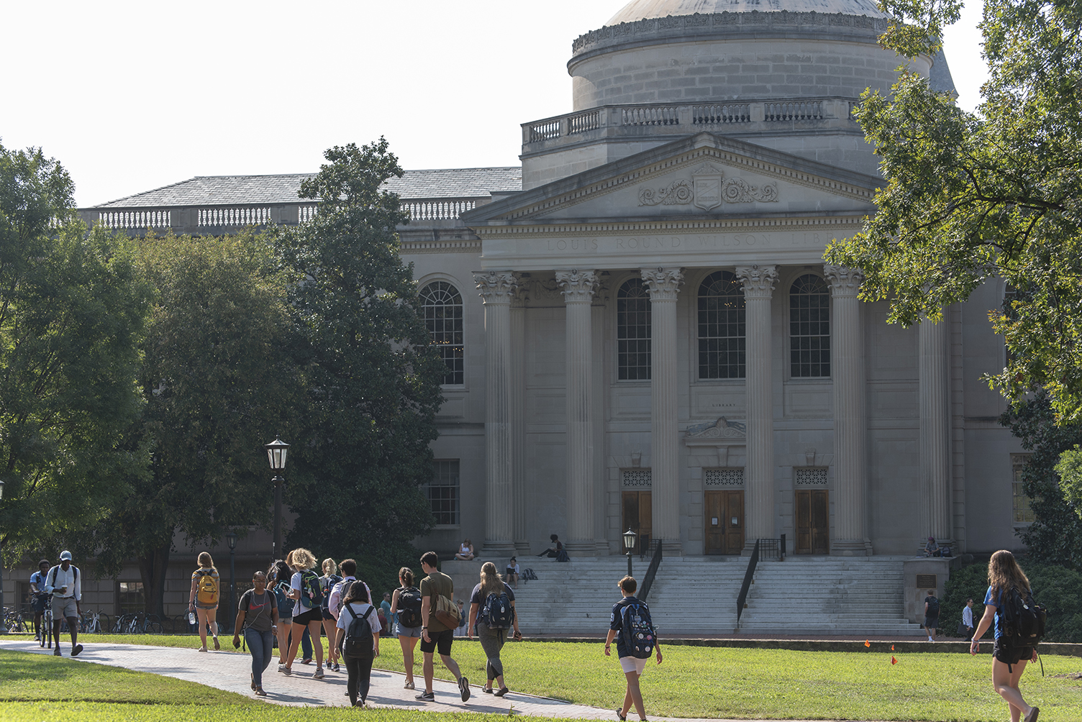

Figure 2. Cinema interior (auditorium seating).
Source/credit: Serge Ottaviani, CC BY-SA 3.0, via Wikimedia Commons (file: L'idéal cinéma-Jacques Tati d'Aniche - la salle.JPG).
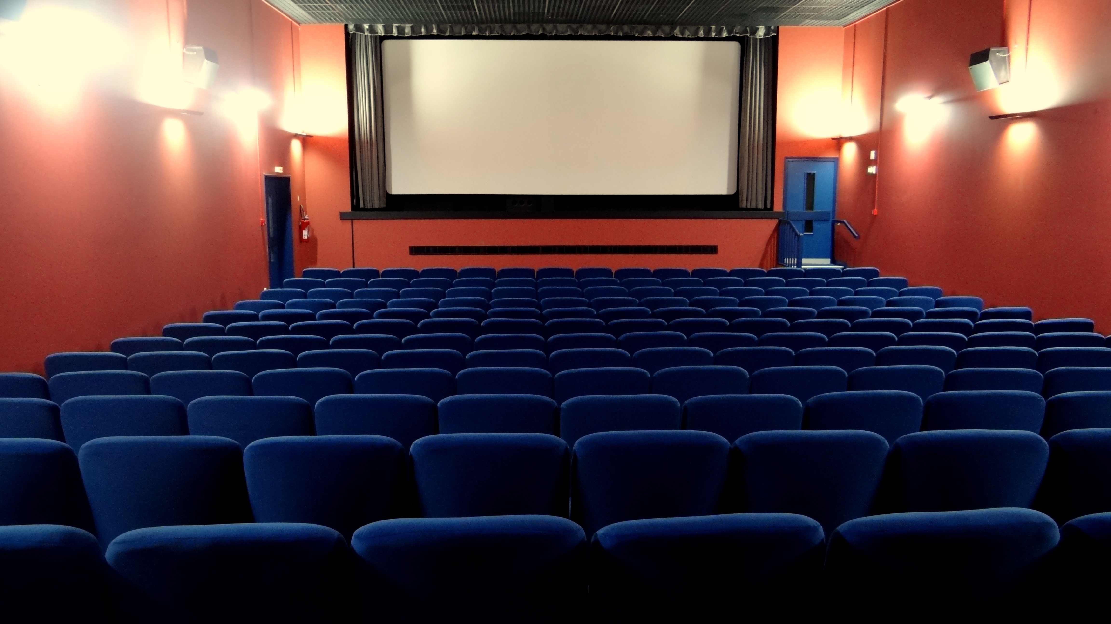

References
Bandura, A. (2001). Social cognitive theory of mass communication. Media Psychology, 3(3), 265–299.
Gerbner, G., & Gross, L. (1976). Living with television: The violence profile. Journal of Communication, 26(2), 172–199.
Green, M. C., & Brock, T. C. (2000). The role of transportation in the persuasiveness of public narratives. Journal of Personality and Social Psychology, 79(5), 701–721.
Hossler, D., & Gallagher, K. S. (1987). Studying student college choice: A three-phase model and the implications for policymakers. College and University, 62(3), 207–221.
Jenzabar. (2024, October 30). New surveys of college-bound students and their parents reveal money matters, but convenience and brand equity may hold more influence when selecting college (Spark451 College-Bound Student Survey & Parent Survey).
National Association for College Admission Counseling (NACAC). (2023). NACAC College Admission Process Survey (conducted by The Harris Poll).
Turner, L. (2017). Social media’s influence on college choice. Journal of College Admission.
Weaver, R., Salamonson, Y., Koch, J., & Porter, G. (2012). The CSI effect at university: Forensic science students’ television viewing and perceptions of ethical issues. Australian Journal of Forensic Sciences.
Wikimedia Commons contributors. (2018). Students walking around UNC [Photograph].
Wikimedia Commons contributors. (2012). L'idéal cinéma-Jacques Tati d'Aniche - la salle [Photograph].

